**CLASSIFICATION USING DECISION TREE AND RULES**

NORTHEASTERN UNIVERSITY - SILICON VALLEY

SUBMITTED TO: SUBMITTED BY:

YIQING WANG ANUBHAV RASTOGI

(PROFESSOR) (STUDENT)

**INTRODUCTION**

Machine Learning is a technique of making a machine learn on its own. It is a study involving algorithms and statistical models facilitating the computer machine to perform the tasks without explicit human instructions. Machine learning is used for analysis of data and forms the part of artificial intelligence. The machine learning algorithms have wide applications as they are used for making predictions through computers. Machine learning algorithms are generally categorized into two main categories: supervised and unsupervised. Supervised algorithms, as the name suggests, are those machine learning algorithms which require to be supervised by a data analyst or a data scientist. On the other hand, unsupervised machine learning algorithms are the ones which do not require any supervision or training with respect to desired outcome result.

There are a variety of machine learning algorithms ranging from simple to highly complex algorithms. These algorithms have a wide variety of applications too. One such algorithm which has been used in this assignment is Decision Tree. Decision tree is a supervised machine learning algorithm having wide usage. This algorithm can be used for both regression as well as classification. The algorithm has a graphical representation in the form of a tree which helps in making a decision. The algorithm is a non-parametric algorithm making hierarchical arrangement about the outcome variables and is represented in a flowchart-like structure. This flowchart-like structure is in the form of a tree containing leaf nodes which represent class labels and the internal nodes representing the attributes. The link or the branch of the tree is a representation of a decision or a rule.

The present assignment contains two parts: Part A and Part B. Both the parts involve different datasets on which the decision tree algorithm is performed. Part A of the assignment contains the German Credit Dataset and Part B of the assignment contains the Mushroom Dataset.

**PART A**

Part A of the assignment involves the German Credit Dataset. This part of the assignment has been performed in Jupyter notebook through Python. In any machine learning algorithm, generally, there are five steps which are to be performed i.e. data collection, data exploration and preparation, training of model, model performance evaluation and lastly, the improvement of model performance. So, the first step of importing packages and extracting of data has been performed. In order to avoid the preprocessing steps, the data has been modified slightly. The dataset contains the loan information obtained from a German-based credit agency.

This modified dataset has been downloaded from the Kaggel so that main focus remains to the building of the model. After the extraction of data, features are loaded, and the target value is set. Here the target value is Credibility column as that column will tell us about the risky bank loans. Thus, y variable contains credibility column and X variable contains all the other columns. The train and test dataset are split in the ratio of 80:20 i.e. 4:1.

The **DecisionTreeClassifier** has been imported from **sklearn.tree** and **Gini Index** criterion has been followed. After fitting the model, the prediction has been made. The error rate is 29.5% and the accuracy rate is 70.5%. Although the accuracy is not bad, the confusion matrix predicts that it is not a good model.

|  |  |  |
| --- | --- | --- |
|  | Predicted Credibility (0) | Predicted Credibility (1) |
| Actual Credibility (0) | 21 | 36 |
| Actual Credibility (1) | 23 | 120 |

After the Gini Index, **Entropy Criteria** has been used which has resulted in the increased accuracy rate and decreased error rate. The precision and recall have been increased too. The classification report is as follows:

|  |  |  |
| --- | --- | --- |
|  | Credibility (0) | Credibility (1) |
| Precision | 0.55 | 0.79 |
| Recall | 0.42 | 0.86 |
| F1-score | 0.48 | 0.82 |
| Support | 57 | 143 |

The confusion matrix has also been improved.

|  |  |  |
| --- | --- | --- |
|  | Predicted Credibility (0) | Predicted Credibility (1) |
| Actual Credibility (0) | 24 | 33 |
| Actual Credibility (1) | 20 | 123 |

Although the accuracy of the model has been increased from 70.5% to 73.5%, yet this not great in the sense that 0 credibility instances have been predicted as more incorrect rather than correct. To improve the accuracy further, the age column has been modified and a new head has been printed. But even after this change, the accuracy remained to be the same without showing any further improvement.

Now, visualization in form of bar graphs has been made for a few columns such as Guarantors, Instalment rate, Occupation etc. with the help of **matplotlib.** The graphs are as follows:

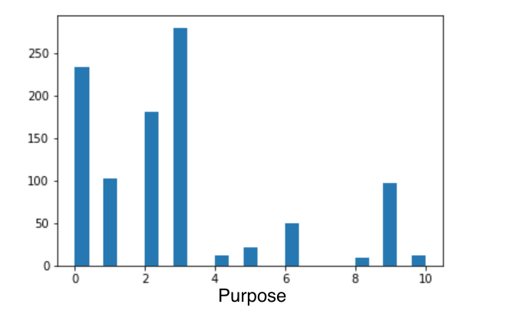 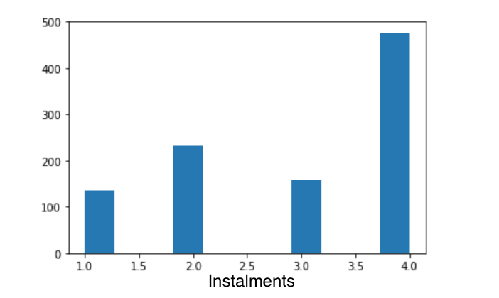

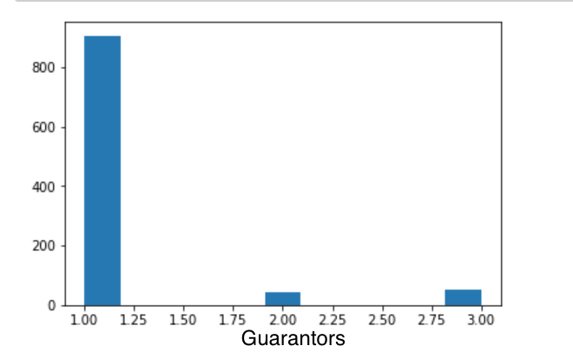 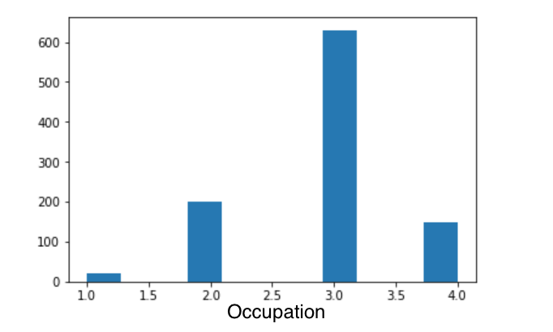

After this, the entire dataset has been grouped as per credibility through **groupby**. Finally, the **tree visualization** has been made and the output has been generated. In this tree, the account balance has been the main root from which the tree stems. The decision tree output is as follows:



Feature Importance has been predicted and plotted to highlight the importance of features. The chart is as follows:

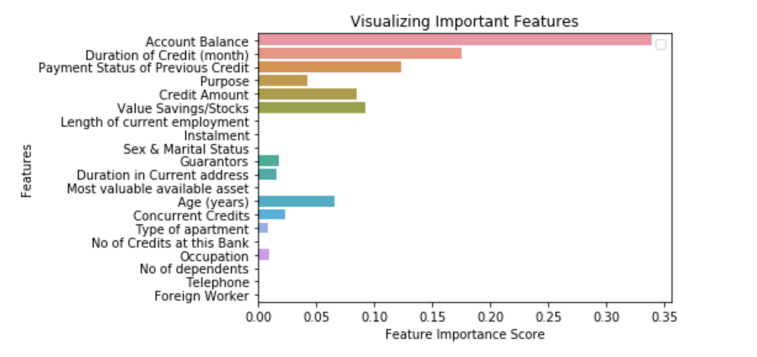

In order to improve the accuracy of the dataset, a column has been dropped and the features and the target value is set again. Now prediction has been made as per **Gini Index**. It can be seen that the accuracy has been improved slightly to 74.0%.

**PART B**

In this Part, the mushroom dataset has been used. This part is also performed in Jupyter notebook through Python. Here also, after importing the necessary packages, the dataset has been extracted and head of the dataset has been printed to get a look of the data. After checking out the data columns and data types, the preprocessing of the dataset has been done. Here, we are supposed to predict the class of mushroom i.e. edible(e) or poisonous(p). The dataset has categorical variables instead of numeric ones, therefore we have applied the lambda function for transforming the data into numeric variables. In order to have a look at the data, **data.head()** has been used.

After preprocessing the data, features are loaded, and target values are set. Here, we have to predict the class of mushroom, therefore y variable is class column and X variable is all the other columns except the class column. The dataset has been split into train and test in the ratio of 4:1. After this, Gini Index classification is used, and predictions are made. The accuracy rate is 98.15% and the error rate is 1.85%. The confusion matrix is as follows:

|  |  |  |
| --- | --- | --- |
|  | Predicted Edible (0) | Predicted Poisonous (1) |
| Actual Edible (0) | 787 | 21 |
| Actual Poisonous (1) | 9 | 808 |

The classification report is as follows:

|  |  |  |
| --- | --- | --- |
|  | Edible (0) | Poisonous (1) |
| Precision | 0.99 | 0.97 |
| Recall | 0.97 | 0.99 |
| F1-score | 0.98 | 0.98 |
| Support | 808 | 817 |

The Precision and Recall along with the confusion highlight the higher accuracy. After, Gini index, Entropy criterion has been used. The confusion matrix and classification report as per entropy criteria is

|  |  |  |
| --- | --- | --- |
|  | Predicted Edible (0) | Predicted Poisonous (1) |
| Actual Edible (0) | 796 | 12 |
| Actual Poisonous (1) | 23 | 794 |

|  |  |  |
| --- | --- | --- |
|  | Edible (0) | Poisonous (1) |
| Precision | 0.97 | 0.99 |
| Recall | 0.99 | 0.97 |
| F1-score | 0.98 | 0.98 |
| Support | 808 | 817 |

The accuracy has been slightly increased to 97.85%. A few visualizations in the form of Bar graphs have been made.

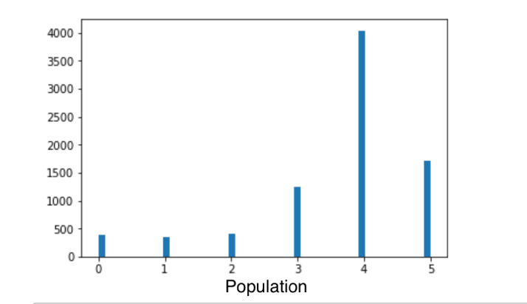 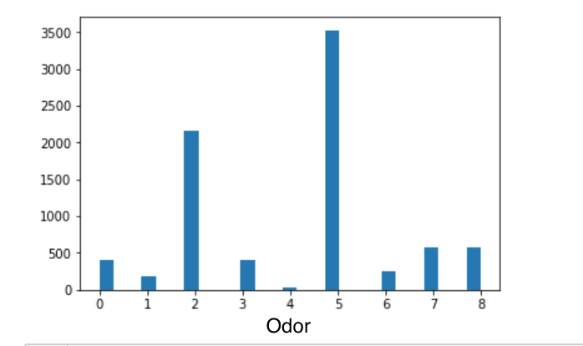

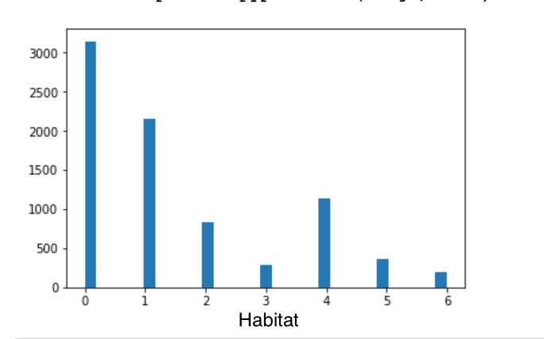 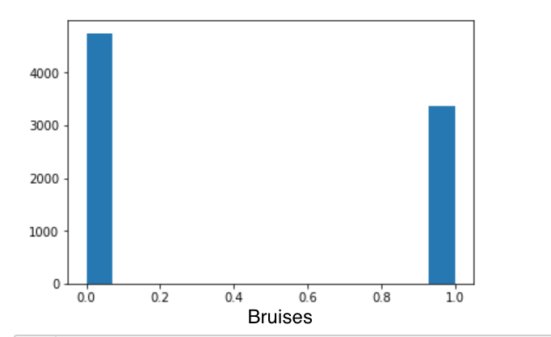

The dataset has been grouped as per the class i.e. edible (0) and poisonous (1). After this, tree visualization has been done and the output of it is as follows:



From the above, it can be seen that gill color has been the root of the decision tree depending upon the presence of spore print color. After decision-tree visualization, the feature importance and feature names have been printed highlighting the significance of each feature in the model.

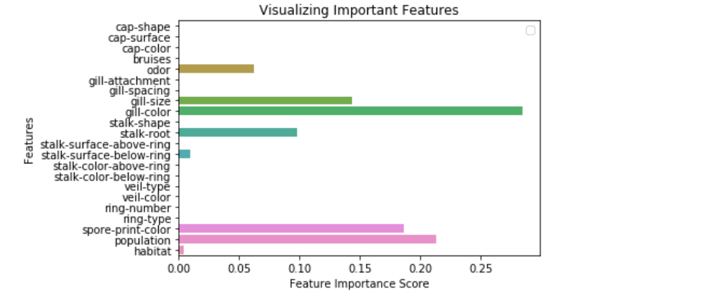

**CONCLUSION**

This brings an end to the report. On the basis of the analysis, it can be concluded that the Decision tree is a tool that contains the possible consequences or the outcomes in a flowchart-like structure. It helps in making an effective decision by clearly laying out the problem. Further, it provides an opportunity to analyze the consequences of a decision. This algorithm is used for performing both regression and classification.

In the present assignment, this algorithm has been used on two different data sets. In Part A of the assignment, this algorithm has been used on German Credit Data to find out the credibility reflecting the risk involved in the loans. The accuracy prediction is 74% which is good but not that great. The decision tree of Part A highlights account balance is the dependent variable majorly relying on the duration of credit and the purpose of the loan. In the real-life scenario, these two variables are really important because these are actually the determining factors of checking account balance to an extent. However, there are a few other factors as well determining the account balance of an individual. Part B of the assignment works on the Mushroom dataset which has categorical variables, as a result, preprocessing has been done to perform the algorithm. The accuracy of the model is extremely high, over-fitting of data can be one of the reasons or maybe the transformed data set is extremely clean with less noise. In both the parts Gini Index and Entropy Classification has been performed to see the change in the model accuracy. It can be said that both Gini and Entropy gives similar results in terms of accuracy. The accuracy of the model in Part B is extremely high as compared to Part A. This highlights that model tuning is further required to boost the accuracy of Part A. Cross-validation is one such technique which can be used to improve the model performance. This brings an end to the report. In the end, it can be said that the decision tree is one of the widely used algorithms for predicting the model. However, it is not the best as Random Forest is ahead of it and produces more accurate results.

**REFERENCES**

* Rahul Saxena. (2017, January 30). How Decision Tree Algorithm Works. Retrieved from <http://dataaspirant.com/2017/01/30/how-decision-tree-algorithm-works/>
* Ed Burns. (2018 May). Machine Learning (ML). Retrieved from

<https://searchenterpriseai.techtarget.com/definition/machine-learning-ML>